Annual Progress Report

Project Title: Empowerment of Victims of Domestic Violence and Human Trafficking in the Transnistrian region of Moldova Project

Implementing Agency: UNDP Moldova
Project Period: June 2014 - May 2016

Reporting Period | June 2014 – February2015
Donor | Government of Liechtenstein
Project Title | Empowerment of Victims of Domestic Violence and Human Trafficking in the Transnistrian region of Moldova Project
Project ID  (Atlas Award ID)  Outputs  (Atlas Project ID and Description)  Strategic Plan and/or CPD Outcomes | 00078796  00088892  Strategic Plan Outcome 4:Gender Equality & Women Empowerment
Implementing Partner(s) | UNDP
Project Start Date | 2014
Project End Date | 2016
Annual Work Plan Budget | Year1 - 157,140 USD  Year2 – 59,860 USD
Total resources required | 217,000 USD
Revenue received | - Regular  - Other  - Donor 217,000 USD  - Trust Fund Cost Sharing  - Thematic Trust Fund C/S  - Special Activities  - EU funding  Total 217,000 USD
Unfunded budget | n/a
UNDP Contact Person | Dafina Gercheva  UNDP Resident Representative  UNDP Moldova
Table of Content

I. Executive summary 3
II. Background 4
III. Progress Review 4
IV. Project Risks and Issues 12
a. Updated project risks and actions 13
b. Updated project issues and actions 13
V. Lessons Learned 14
VI. Conclusions and Way Forward 14
VII. Financial Status 15

- Executive summary
Overall Objective of the action:
Enhancing Protection to victims and potential victims of human trafficking and domestic violence through a strengthened system and Empowerment of individuals to prevent and address the problems at their roots in the Transnistrian region.

Specific objectives:
• Provide support in the establishment, institutionalization and functioning of social reintegration/rehabilitation service, including the establishment of at least one shelter for the victims of violence and human trafficking
• Strengthen the capacity of key service delivery institutions to promote and protect women's rights to life free from violence and those of the victims of the human trafficking
• Raise public awareness to support prevention and disclosure of DV and HT instances
• Support the ability of relevant civil society organizations and activists to advocate for a strengthened rules/protection framework for victims of DV, HT and other forms of violence against women, as well as of victims to stand and claim rights.
• Educate women from grassroots’ networks, as well as women from particularly marginalized communities, to understand and support the human rights standards to help fight gender-based violence and exert a positive impact on the lives of women and girls and, by extension, civilian communities as a whole.
The above mentioned objectives will be tackled through the following project activities:
1. Support the establishment, institutionalization and functioning of social reintegration services /center (shelter) for the victims of violence and human trafficking
2. Strengthen the capacity of key service delivery institutions to promote and protect women's rights to life free from violence and those of the victims of the human trafficking
3. Raise public awareness to support prevention and disclosure of the instances of VaW and HT and support the empowerment of victims

Beneficiaries: Victims of DV and HT, pregnant women at risk, de-facto local authorities, local stakeholders, specialized public institutions

Implementing Agencies: UNDP, OHCHR, UNFPA,IOM

Partners: UN Women, NGOs, Liechtenstein Development Service

Expected results:
• A social reintegration service/center (shelter) to provide assistance to victims of DV and HT in the Transnistrian region established and functional
• Network/empowerment group of victims enabled or, if not feasible, then victim empowerment services created for example via confidential online internet platform or closed social media group, as needed.
• Capacities of key stakeholders to protect and assist various socially marginalized groups strengthened
• Public awareness raised to support prevention and disclosure of DV and HT instances
• During the first year of the new social services activity, the following results will be achieved:
- 30 mother-child couples integrated
- 15 pregnant women at risk assisted
- More than 100 victims of DV and HT counselled.

- Background
Violence against Women (VAW) is widespread in Transnistria. Though there is no official data available on prevalence rate on violence against women, studies indicate that during the year, 35.7 percent of women in Transnistria experienced physical domestic violence, 22 percent were beaten by their current husband/partner, 10.7 percent were beaten publicly, and 5.2 percent were sexually abused by their partner.
There are no frameworks designed to prevent and halt this phenomenon. Victims of violence cannot benefit from assistance since there are no emergency shelters and relevant services, except the one carried out by NGOs. Victims are frequently left without any psychological support and legal assistance. Enforcement personnel are often not prepared to handle cases of VAW in the interest of the victim.
The region is a “source area” for victims of forced labour and commercial sexual exploitation.
Despite the existence of regulations consecrated to combating trafficking there are problems with implementation. Preventive and counselling efforts run by local NGOs are insufficient to deal with this form of slavery. The work already initiated to reform the enforcement structure for counter-trafficking can benefit further from international exchange, including with authorities in Chisinau as well as with others in the neighbourhood.

- Progress Review

Since the project start in July 2014, and till December 2014, the project team succeeded to make important advancements in all key areas: center’s profile development, important partnerships established; raising public awareness. During the reporting period, the project team has focused on the following activities, which ensured the continuity of project’s implementation: finalizing the process of selecting the NGO partner, signing the Grant Agreement, selecting and training the Centre’s staff, and also continuing the dialogue with the de-facto authorities regarding the identification of adequate space for the future shelter.
Regarding the use of the financial resources, during the reporting period, 106,854.80 have been expensed (representing about 50% of the total project budget of 217,000 USD).

Further key developments per activities are presented below:
UNDP is the agency responsible for the implementation of the 1st activity supporting the establishment, institutionalization and functioning of the social reintegration services /center (shelter) for the victims of violence and human trafficking.
  - Elaboration of the Center Concept: during the reporting period, according to the Project Work Plan, the Center’s Profile has been elaborated and consulted with the relevant stakeholders, direct links have been established with the local authorities and NGOs from the left bank and discussions were initiated concerning the identification of the appropriate NGO/locality where the shelter will be placed. Additionally, a general work plan and budget plan covering the entire project operations have been developed.
1.1.1. Design Center’s Profile: The Center’s Profile was designed in collaboration with the main relevant stakeholders. In this sense, two round tables have been organized in Tiraspol, on July 17th, 2014, by the local NGOs. Along with other topics, related to domestic violence and trafficking of human beings in Transnistrian region, a high interest was sparked by the Concept of the future Center, named “Center for Assisting Women in Situations of Danger”.
The discussions were made based on the draft of Center’s Profile prepared by the project team; representatives of OSCE, IOM, and 5 NGOs from the left bank have been involved in these discussions.
Based on the suggestions received from the stakeholders, the project team succeeded to better define the Center’s Profile, incorporating the following essential characteristics:
- The Center will have a well-defined specialisation established in compliance with the real needs of the assisted target groups (i.e. victims of domestic violence (and their children), victims of human trafficking (and their children), including teenagers);
- Special attention will be paid to those services which are currently lacking in localities (midterm psychological and social assistance, job opportunities, temporary placement for target groups, etc.);
- The Center’s activity will be focused on two main areas: 1) it will provide temporary placement services to those beneficiaries that need temporary housing and 2) day care centre - opened for beneficiaries from community that don’t require temporary housing.
1.1.2. Partnership development: In order to facilitate and fortify the project implementation process several cooperation links with relevant stakeholders have been established:
- International Agencies: IOM, OSCE;
- Local NGOs: Interaction, Resonance, Jenskie Initiativi, etc;
- Local authorities’ institutions responsible for local Labour and Social affairs.
1.2. NGO/Locality Identification - In order to facilitate and strengthen the process of NGO and Locality selection for the future Center, negotiations with local authorities regarding the identification of the appropriate location and building were conducted. During the joint meeting with the local authorities and project staff held on July 17th, the representatives of the de facto ministries from the Transnistrian region had the opportunity to receive comprehensive information about the project’s goal and objectives, main implementing mechanisms, target groups, project partners, as well as information on NGOs and localities identification and selection criteria. During the discussions, the local authorities expressed their interest and willingness to support the project, especially in identifying the appropriate building for the location of the future center.
1.2.1. Selection of the NGO to run the future Center for Assisting Women in Situations of Danger
In order to meet this goal the «Strengthening Human Rights in Transnistrian region of Moldova» Project announced an Expression of Interest on 21 July 2014, inviting non-profit organizations from left bank of Nistru River to submit their applications until 11 August 2014, 16.00 pm. Due to the fact that only two applications have been received by the announced deadline, the competition has been extended until 25 August 2014, 16.00, thus ensuring participation of a larger number of applicants. Within this Expression of Interest, the Project intended to select an NGO partner from the Transnistrian region that will be responsible to manage the daily activity of the future Centre for assisting Victims of Domestic Violence and/or Victims of Human Trafficking.
One of the key criteria for selecting the NGO is the demonstrated involvement of the NGO in the field of preventing and combating violence against women (VAW) and/or human trafficking (HT) and implementation team directly working with beneficiaries – victims of DV and/or HT – possess knowledge and abilities to work with this specific target group.
Despite extension of the deadline with two more weeks, only 2 (two) applications have been submitted: NGO Centre of Reproductive Health from Tiraspol and NGO Centre Resonance from Bender. Both have met the minimum administrative requirements and have been allowed for the 2nd evaluation stage.
The Selection Committee held its first meeting on September 23, 2014, to evaluate both applications. Members of the Selection Committee have debated on the capacity of applicants and finally it was decided to hold separate meetings with each NGO (including their full implementation team) to identify the best candidate.
During the discussions, held on September 26, 2014, the members of the Selection Committee have verified that the profiles of the NGOs and their members correspond to the objectives and priorities of the project: have experience and knowledge in working with the target groups; have sufficient and knowledgeable specialists to assist the beneficiaries; their relationship with local administration, donors community, experts community from inside and outside the country; capacity to ensure continuity and sustainability of the Centre.
Therefore, on October 20th, 2014, based on final cumulative evaluations submitted by the Selection Committee’s members, the NGO Centre Resonance from Bender is recommended for approval to the «Strengthening Human Rights in Transnistrian region of Moldova» Project Board.
1.2.2. Sign partnership agreements with NGO
At the distance of one month after the selection, timeframe during which the project team and the selected partner have negotiated the work plan and the budget, on November 26, 2014, the Grant Agreement was signed.
1.3. Creation of the Centre for Assisting Women in Situations of Danger (CAWSiD)
1.3.1. Negotiations with de-facto authorities regarding appropriate locations and buildings
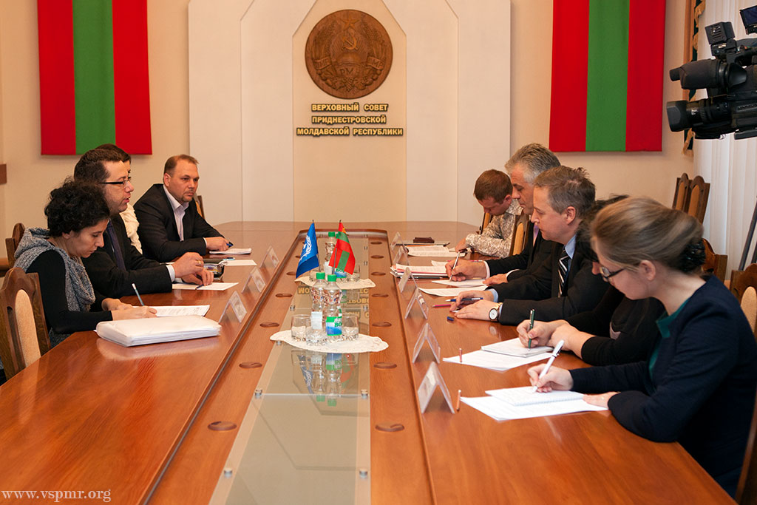
Concurrently with assessing of the pre-selected NGOs’ capacities, the project representatives have started discussions with the de-facto authorities to offer appropriate premises to establish the CAWSiD. Thus, during September 2014, negotiations were conducted with the representatives of de-facto Ministry of Internal Affairs, and Ministry of Social Protection. Despite the interest shown while negotiating the establishment of CAWSiD, in fact, no action was undertaken by the authorities in terms of identification of the appropriate premises for the future Centre. In order to accelerate this process, the project team required support on this issue from the de-facto parliament’s representatives. Together with Claude Cahn, OHCHR Human Rights Adviser, we have met with the de facto vice-speaker of parliament, Mr. Ceban, and with the other members of parliament and representatives of ministries of Internal Affairs and Social Protection. We have presented the project’s results achieved and requested support to identify the building for the future Center and also to adopt the legislation in combating Domestic Violence in Transnistrian region. The de -facto representatives of parliament assured of their continuous interest to work closely with the UN agencies, due to our common effort to solve the local social problems.
1.3.2. Start assisting victims in the temporary shelter
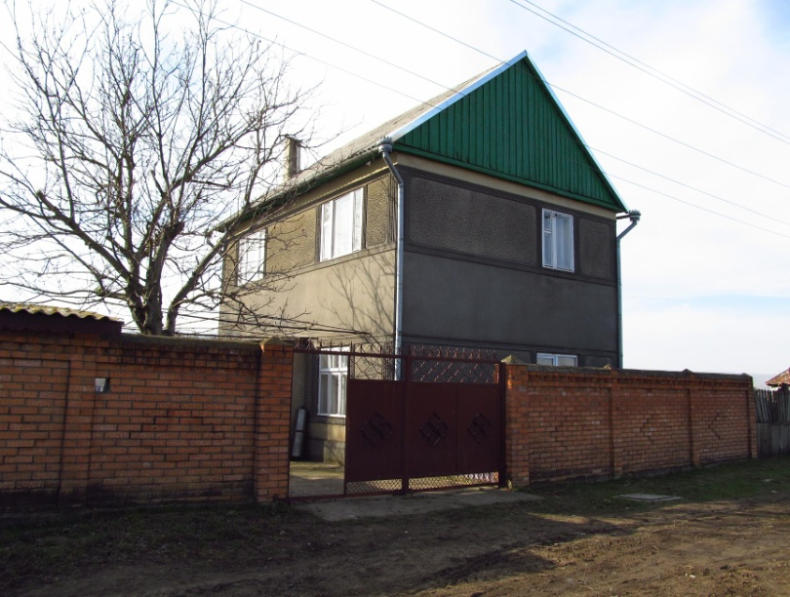
Simultaneous with the process of selecting of the partner NGO, two issues came out particularly:
1) lack of high-skilled professionals - especially the social workers which can provide services to survivors of Domestic Violence - because the local higher education institutions do not offer these specialties; and 2) the absence of available buildings owned by the de-facto authorities, due to the excessive concentration of socio-economic activities only in two towns of the region - Tiraspol and Bender - and at the same time, the nonappearance of new constructions, connected with the crisis in real estate investments.
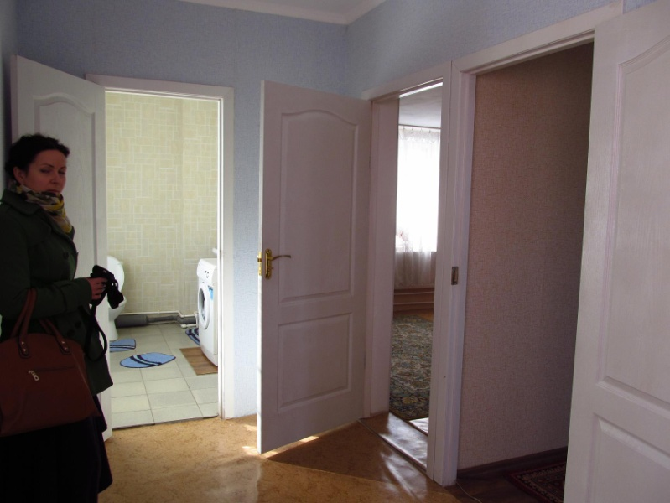
Being aware that the process to ascertain the available space can take longer than it was initially envisaged, the project team has elaborated an intermediary step, thought for starting work with survivors of Domestic Violence and to achieve the assumed outputs. The idea consists in renting up to two adequate houses from private sector (one in Bender and another in Tiraspol) which will become temporary shelters, until the permanent shelter will be identified, retrofitted and finally commissioned to the local partners.
At the moment, one house in very good condition is rented in Bender, for a period of 12 months. The house allows assisting in a residential regime at least 5 survivors of Domestic Violence, with their children. Therefore, this way allows the project and partners (i) not to postpone the process of assisting beneficiaries in need and (ii) to gather the necessary experience till the core shelter will be opened. Today, our NGO partner works to improve the building's safety, by installing the alarms and video surveillance, as well as make all the necessary arrangements for a comfortable staying of beneficiaries. It is expected that the first beneficiaries can be assisted in a residential regime not later than early April.
1.4. Strengthening CAWSiD capacities
1.4.1. Selection of centers’ staff
Taking into consideration that the NGO-partner is lacking the appropriate human capacity (specialists on social reintegration issues), it was announced an open competition to select the Center’s staff, in view of employing qualified staff to deal with the beneficiaries. As a result the Social Worker was employed.
1.4.2. Strengthening the capacity of inter-disciplinary team to render qualitative services
Study visit
During 15 - 17 December, 2014, the project team has organized and conducted a study-tour to the right bank of Nistru River, for 3 NGO teams from Transnistrian region. The overall purpose of the study-tour was to visit several Social Centres (services) for survivors of Domestic Violence and Human Trafficking, and familiarize NGOs from Transnistria with the experience and best practices of similar organizations, as well as the operational and quality standards, types of social services rendered to beneficiaries, working tools and methodologies.
Internship
Continuing strengthening the capacity of the selected staff, it was organised a two-week internship at Drochia Maternal Centre for two specialists, members of the Centre's team from Transnistrian region.
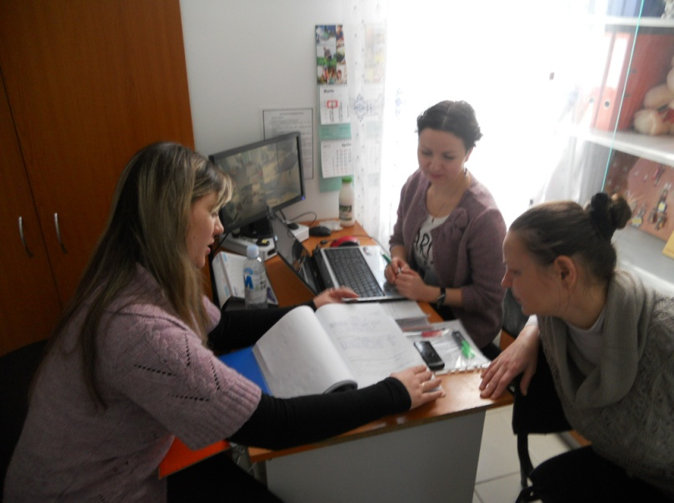
The internship’s objective was to strengthen professional capacity of staff, directly involved in the identification and direct work with survivors of DV and/or HT, specifically tailored to the social workers and psychologists.
The main topics studied were: Case management, working instruments, reintegration stages and the needs of assisted beneficiaries. Along with theoretical aspects of working with beneficiaries, the interns appreciated the possibility to understand and apply the practical aspects.
The internship resulted in:
- consolidation of the professional knowledge of 2 professionals working with survivors of DV and HT (psychologist and social worker) representing main organization’s actors in assisting the survivors;
- strengthening inter-organizational relations and best practices/experience sharing on the national level;
- transfer of best international practices and its adoption to the national situation;
- identification of additional training needs of the professionals, therefore the training activities for staff, study visits to the right bank will be continued and will also include other specialists from the left bank.
According to the project document, OHCHR is responsible for implementing the 3rd activity, framed around “Raising public awareness to support prevention and disclosure of the instances of VaW and HT and supporting the empowerment of victims”.
Below is presented a snapshot of key achievements under Activity 3, during the implementation period:
3.1. Support the development of victim/survivor groups and networks, as well as modes of mutual support by persons affected
The non-governmental organisation “Women’s Initiatives” has pioneered the Self-Help Groups (SHGs) program in the Transnistrian region of Moldova to support women who experience situations of violence. A group of women concerned about finding strategies to address violence received support in arranging common gatherings in which they shared their experiences, feelings and supported each other. These meetings resulted in: an increased understanding amongst the women from Slobozia district of the conception of violence against women as a problem of unequal power relations between genders and a violation of human rights; capacitation of women who experience violence to build their personal strategies to address violence, integrating individual and group support; and advocacy for the development of appropriate regulatory provisions on prevention and interventions in cases of domestic violence and public policy measures on rehabilitation and social inclusion of victims.
The group serves as a resource for many women at risk of serious harm as a result of domestic violence helping them to break the silence and, without anyone impose a route or a recipe to exit violence, identify their own strategies to end violence in family and gain self-determination.
The mobilized group of women came forward and raised their voices against domestic violence in a groundbreaking action aimed at making the issue of gender based violence visible to the community and supporting the establishment of the first shelters for girls and women in crisis situations.
3.2. Support the organization of awareness raising campaigns and joint events (involving the right bank) on domestic violence and human trafficking
The NGO Interaction team coordinated the joint efforts of NGO Women initiatives, NGO “Center Lada”, NGO “Center Resonance”, NGO “Social aspect” around the international campaign on 16 Days of Activism Against Gender Violence (25 Nov. – 10 Dec. 2014). As part of the 16 Days of Activism against Gender Violence, local 'orange' events were successfully conducted, including panel discussions on television programmes and street actions to raise awareness and public engagement.
On the 19th of November a training on international complaints procedures for human rights violations allowed lawyers and human rights activists the opportunity to increase their abilities to support victims of domestic violence with filing individual petitions to the UN treaty bodies for bringing real meaning to the right to be free from gender based violence and discrimination and obtain redress for violation of their rights. The organizations working in the field of domestic violence have increased their knowledge on the strategic potential of engaging with the UN Committee on Elimination of Discrimination against Women for advancing legislative reform and catalyzing a stronger commitment of the state bodies to act with due diligence in the cases of domestic violence.
NGO Interaction engaged with the platform of organization supporting the women’s right cause, the representatives of Tiraspol juridical institute (TJI) and the de facto authorities from the Supreme Soviet and finalized the draft regulatory framework on combating gender based violence presented for public debates at the forum of the de facto legislature in December 2014.
3.3. Facilitate the establishment of a women’s forum, including ensured representation of marginalized segments of women, and exercise a convening role as enabler of women to engage in dialog with authorities, participate in the development of national policies in the field of gender-based violence and hold the promise of leading social and institutional change
The platform of non-profit organisations representing the interests of women have carried out a series of activities to prepare the public awareness on the issue of domestic violence and current legislative gaps which make it impossible to punish perpetrators and to make proper use of legal remedies, thereby limiting the enforcement of women’s rights.
3.4. Exchange of experience with one of the EU countries on efficient response and operation of key stakeholders addressing violence and human trafficking including visits to the right bank
During the period of 16-19 November two members of the Resonance non-government organisation, which are responsible for coordinating the establishment of the first shelter for women and children victims of domestic violence in the Transnistrian region and the representative of the de facto executive institution which took the lead in coordinating the efforts on legislative reform have participated to the 16th annual conference on gender based violence organized by the network of Women against Violence in Europe, held in Vienna to strengthen their understanding of the global outlining of the issue and learn from the European experience on the best ways to take actions for the adoption of a comprehensive rules framework and act with due diligence in preventing violence, protecting survivors and providing services for victims.
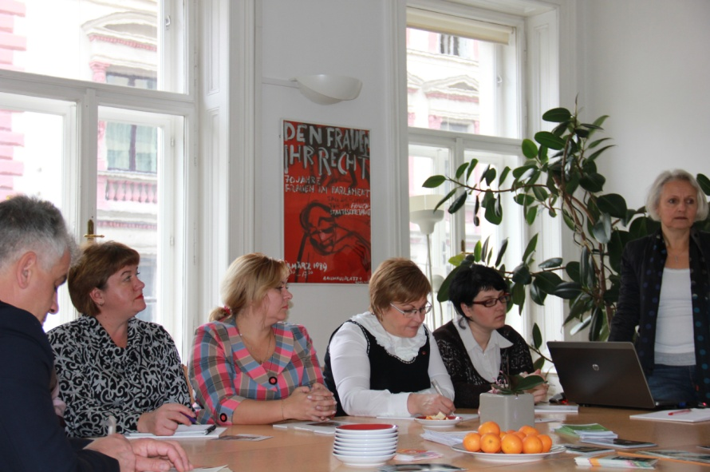
On the 20 to 21 of December the group was joint by a delegation of four de facto authorities holding key positions in the legislative and executive bodies and three representatives of women’s NGOs providing services to victims of domestic violence aiming to participate in bilateral meeting with the Austrian Ministry of Education and Women, the Viennese Police Office, the Office of the Viennese Women’s Shelters, the nationwide Helpline Operator, and the WAVE main office. This unique learning experience has solidified the understanding of the institutional response to gender based violence in Austria and mobilized thinking on transposing the experience to the Transnistrian context.
The study visit was ground breaking because from the perspective of convening together for the first time key representatives of the de facto legislative body and executive branches responsible for harmonization of the internal rules framework to the international human rights standards and active civil society representatives advocating for gender equality and fighting against domestic violence. A constructive dialog between the parties has been enabled creating further opportunities for moving the reform process forward.
Separately, NGO Interaction organized a study visit of a group of non-profit organisations, representing the interests of women, to Belarusian Orthodox Church Union sisterhoods “Beneficence” and facilitated participation at the international conference with the participation of the Russian and Belarusian orthodox churches, Polish catholic churches; NGO “Trust line “Gender perspectives”, NGO “Belarusian association young Christian women”, NGO “Radislava” (Crisis center for women); Ministry of labour and social protection of Belarus and MIA of Belarus. The aim of the visit was to get familiarized with the work on preventing violence against women in the countries of post-communism transition, namely the identification of positive practices related to the introduction of special regulatory framework to ensure emergency protection orders and shelter to victims of violence.

- Project Risks and Issues
The topics such as Domestic Violence, Human Trafficking and/or Juvenile Justice have become political and religious topics with negative trend, which make the decision factors stay away from these sensible themes. We face with situation in which the tandem politicians-local Orthodox Church can cause delays and deviations in the implementation of the project.

The Orthodox Church, which plays an influential role on the territory of the Transnistrian region, initiated a public discourse that justifies or explains the violations of women’s rights, including gender based violence. In opposition to the adoption of a normative framework on violence against women, the church imposes direct pressure on the de facto legislative body invoking notions of tradition and religion and threatens to influence the populations’ vote in the upcoming “elections”.
Despite the fact that a draft law on eliminating violence against women was presented in the legislative body for adoption, the project had to be removed from the agenda because of the alleging suspicions of the motives of women rights organizations and fearing disguised “western” political imposition.
Against these circumstances, the adoption of a dedicated Law on Combating Domestic Violence is expected to be tergiversated.

- Updated project risks and actions

Project Risk 1: Lack of support on behalf of local authorities in finding an adequate building for the future Center.
Actions taken: To continue dialogue, through meetings, commonly with the local NGOs and de facto authorities and to remind of the background for which this Programme was set, the benefits from this project and how the results will contribute to diminish the phenomena of Domestic Violence and Human Trafficking.

Project Risk 2: Lack of political commitment to transfer into local practice the international standards on gender equality and freedom from gender based violence.
Actions taken: Organize follow up meetings on Hammarberg, and the deputy High Commissioner for Human Rights visits to the transnistrian region, bilateral dialogs with the key de facto authorities and joint round tables, including active participation of the civil society aiming at raising awareness on the international law and best practices available.
- Updated project issues and actions

Project Issue 1: Low and declarative interest, displayed by local authorities in combating Domestic Violence and Human Trafficking.
Actions taken: To encourage local authorities to implement step by step the local action plan, regarding Domestic Violence and Human trafficking issues. To stimulate local NGOs in terms of providing lobby and advocacy for adopting the local law regarding combating Domestic Violence phenomena.
Project Issue 2: Marginalized participation of the civil society in the process of drafting and adopting rules and regulations
Actions taken: Facilitate and build the dialog between the de facto authorities and civil society representatives to encourage de facto authorities to engage with the civil society and ensure fair participation in the decision making process.

- Lessons Learned
Due to the precarious financial situation in the region, (cutting of the pensions, reducing of salaries), the decision factors (representatives of de-facto ministries) do not to give priority to the phenomena such as Domestic Violence and Human Trafficking. Despite of a permanent dialogue, till now the de-facto authorities haven't identified any potential spaces, which may respond to our requirements. It was also attested that some local politicians try to use these topics as part of their election agenda.

- Conclusions and Way Forward
During the Upcoming period, the project will continue the implementation of planned activities, accordingly to the Project Work Plan, focusing on:

UNDP
- a series of site visits to select the second house in Tiraspol, which will be used as a temporary shelter like in the Bender case;
- organize a number of seminars and trainings with the selected NGO staff who will run the Centre;
- facilitate the developing of the own set of administrative and specialized documents for the Centre (regulations, reintegration plan, documents for referral system, etc.)
- facilitate and speed up the dialogue between de-facto authorities, the project and the implementing partner regarding identification of adequate space for the future shelter.

OHCHR
- ensure expert guidance and support for women rights organizations advocacy initiatives aiming at the adoption of a comprehensive normative framework on gender based violence in conformity with the international human rights law and standards.

- Financial Status

